

SCHOOL OF COMPUTER SCIENCE AND ENGINEERING

**CASE STUDY ON H.R_ANALYTICS**

**Submitted By: Kannikaa.D(R22EF278)**

**Rukmini Knowledge Park ,Kattigenahalli ,Yelahanka,**

**Bengaluru-560064** [**www.reva.edu.in**](http://www.reva.edu.in/)

Visualizations using HR analytics in Power BI enable organizations to transform complex data into intuitive dashboards, providing actionable insights into employee performance, attrition rates, and workforce trends. These visual tools help HR professionals communicate key metrics effectively to stakeholders. Visualizations using HR analytics in Power BI enable organizations to transform complex data into intuitive dashboards, providing actionable insights into employee performance, attrition rates, and workforce trends. These visual tools help HR professionals communicate key metrics effectively to stakeholders.

**Here, we are analyzing the count of employees,Arttrition count,Attrition Rate,Average of Age,Average of Salary,Average of Experience:**

A **Card** in Power BI is a simple visualization used to display single, aggregated values for key metrics. It is ideal for presenting at-a-glance information or KPIs (Key Performance Indicators). Cards help highlight important figures that users need to monitor, such as totals, averages, or percentages

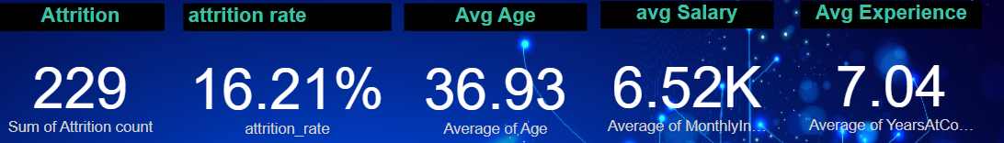

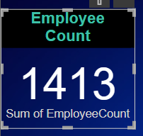



**Here,we are analyzing the Sum of Attrition Count by AgeGroup:**

A **Stacked Bar Chart** in Power BI is a type of chart used to represent data segmented into parts that make up the whole, displaying these parts as bars stacked on top of each other. Each section of the bar represents a different subset of the data, enabling users to see both the total and individual segment contributions.

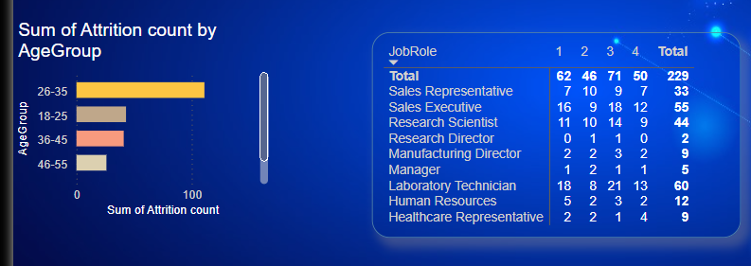

**Here, we are analyzing the Sum of Attrition Count by Salary Slab:**

A **Stacked Column Chart** in Power BI is a type of chart that visualizes data using vertical bars, where each bar is segmented to show the composition of subcategories within a total value. This allows viewers to see how individual parts contribute to a whole and compare these contributions across different categories.

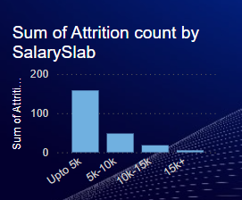

**Here, we are analyzing the matrix for Job Role as Rows,Job Satisfaction as Columns to the Attrition Count:**

A **Matrix** in Power BI is a versatile visualization similar to a pivot table, allowing users to display data in a tabular format with rows, columns, and values. The matrix can display hierarchical data and provide a comprehensive view of data intersections, making it ideal for detailed comparison across multiple dimensions.



**Here, we are analyzing the Sum of Education By education Field:**

A **Pie Chart** in Power BI is a simple yet effective visualization tool that displays data as a circular chart divided into slices, where each slice represents a proportion of the total. It is used to show the relative size of categories in a dataset, making it easy to compare parts of a whole at a glance.

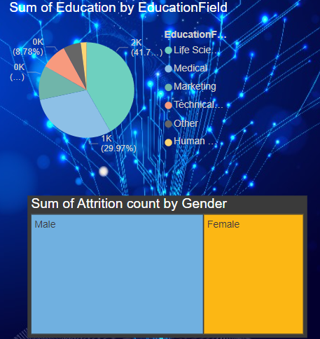

**Here,we are analyzing the Sum of Attrition Count By Gender:**

A **Treemap** in Power BI is a visualization that displays hierarchical data using nested rectangles. Each rectangle represents a category within the hierarchy, sized and colored based on a numeric value associated with that category. Treemaps are useful for showing proportions within a dataset, revealing patterns, and comparing the relative sizes of components within a larger group.

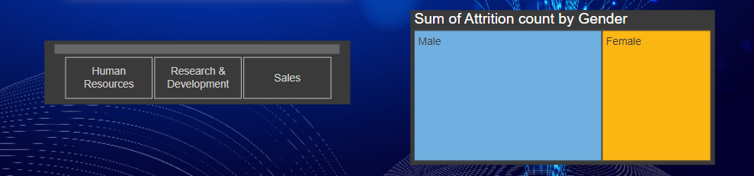

**Here,we are analyzing the slicer for Department:**

A **Slicer** in Power BI is a visual filter that allows users to interact with a report by selecting criteria that dynamically filter data in other visualizations on the page. It acts as an interactive control, enabling viewers to quickly drill down into data and focus on specific segments without navigating away or modifying the report layout.



# THANK YOU